**Assignment**

**Self-hosted runner**

**Ans:**The steps to create a self-hosted runner on GitHub is as follows:

1. Set up a machine or virtual machine: Choose a machine or virtual machine that meets the requirements for self-hosted runners. It should have a supported operating system (Windows, macOS, or Linux) and sufficient resources to run the desired workflows.
2. Install Git: Install Git on the machine or virtual machine. You can download Git from the official website (https://git-scm.com/) and follow the installation instructions for your operating system.
3. Install the required dependencies: The self-hosted runner has a few dependencies that need to be installed. These dependencies include the GitHub Runner software and any other tools required for your workflows. Refer to the GitHub documentation for specific dependencies based on your operating system.

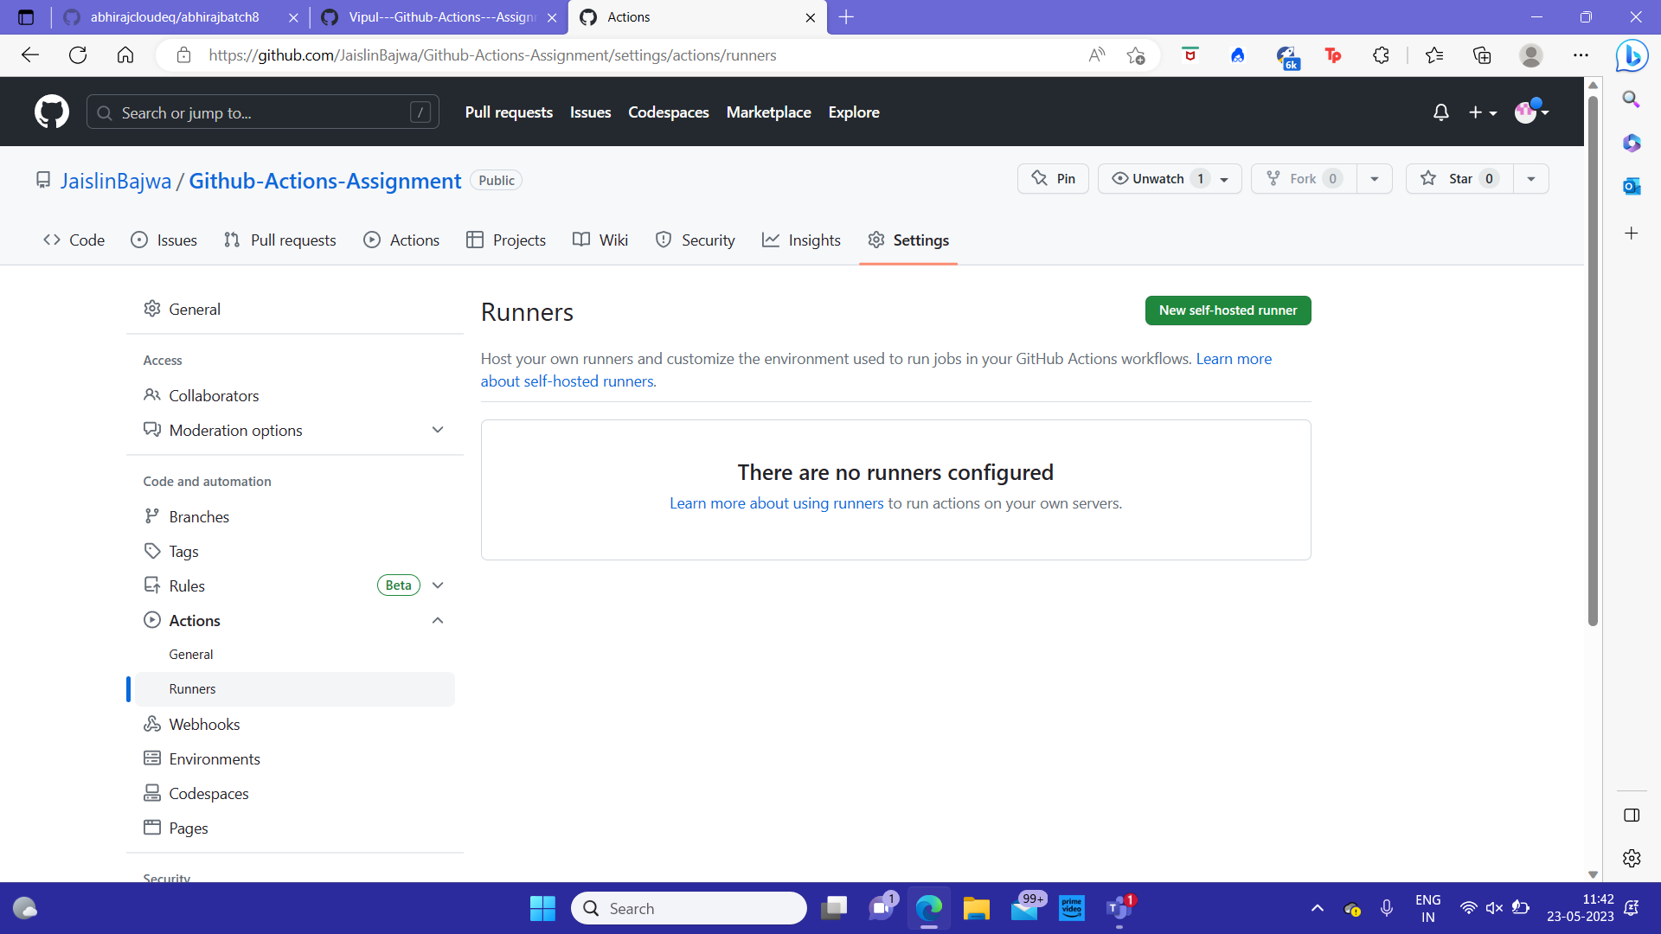

1. Get the self-hosted runner application: Visit your GitHub repository and go to "Settings". Under "Actions", click on "Add runner" to access the runner download page. Download the self-hosted runner application for your operating system.Now open the powershell and download the directory using the following commands:

# Create a folder under the drive root  
$ mkdir actions-runner; cd actions-runner# Download the latest runner package  
$ Invoke-WebRequest -Uri <https://github.com/actions/runner/releases/download/v2.304.0/actions-runner-win-x64-2.304.0.zip -OutFile actions-runner-win-x64-2.304.0.zip>

# Extract the installer  
$ Add-Type -AssemblyName System.IO.Compression.FileSystem ; [System.IO.Compression.ZipFile]::ExtractToDirectory("$PWD/actions-runner-win-x64-2.304.0.zip", "$PWD")

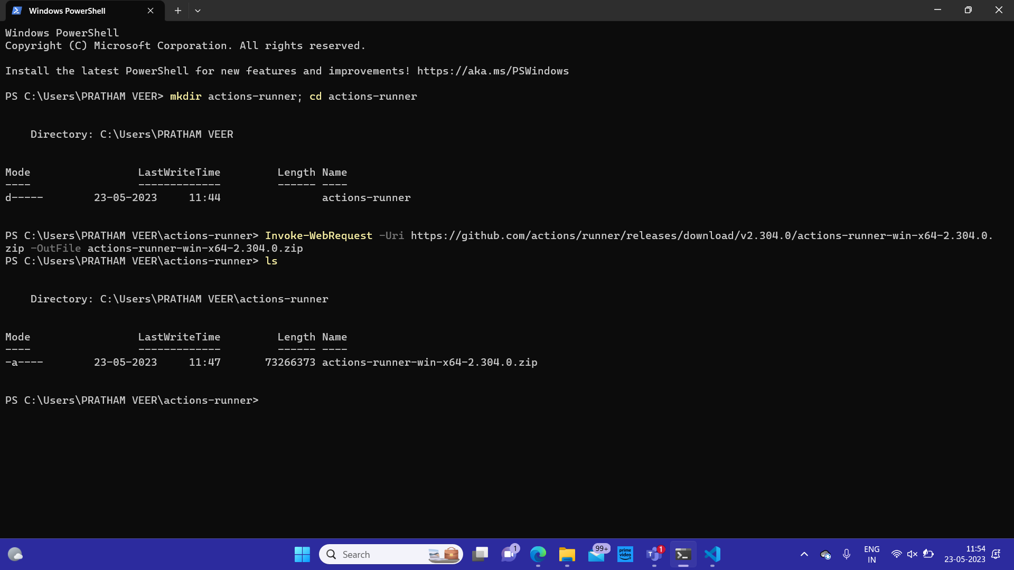

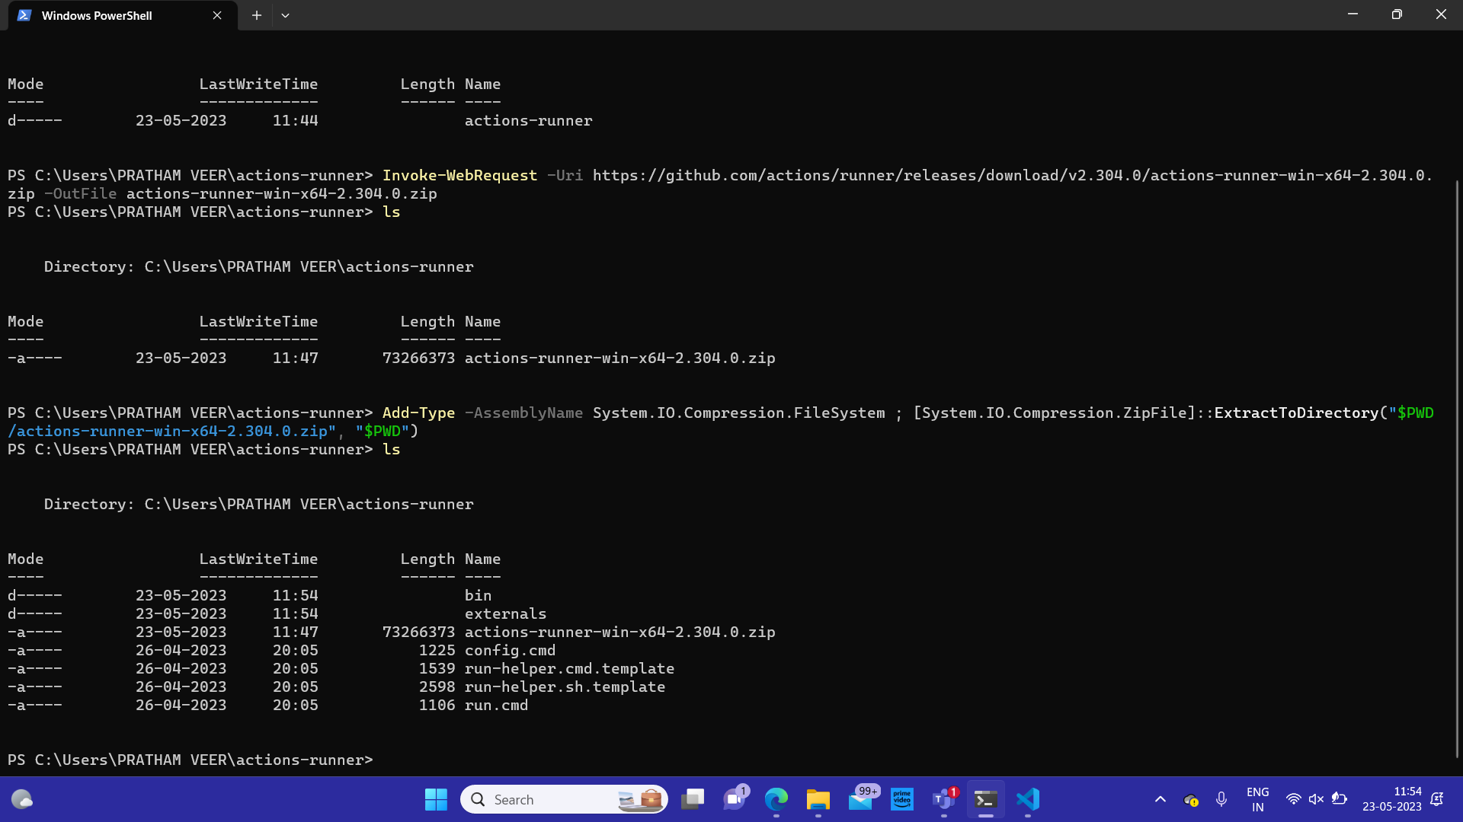

1. Configure the self-hosted runner: Extract the runner application and navigate to the directory where it's located. Run the configuration script or executable to set up the runner. The configuration process will prompt you to enter your GitHub repository URL, access token, and other necessary details.
2. Start the self-hosted runner: Once the runner is configured, start it using the provided command or executable. The runner will establish a connection with GitHub and become available for use in your workflows.

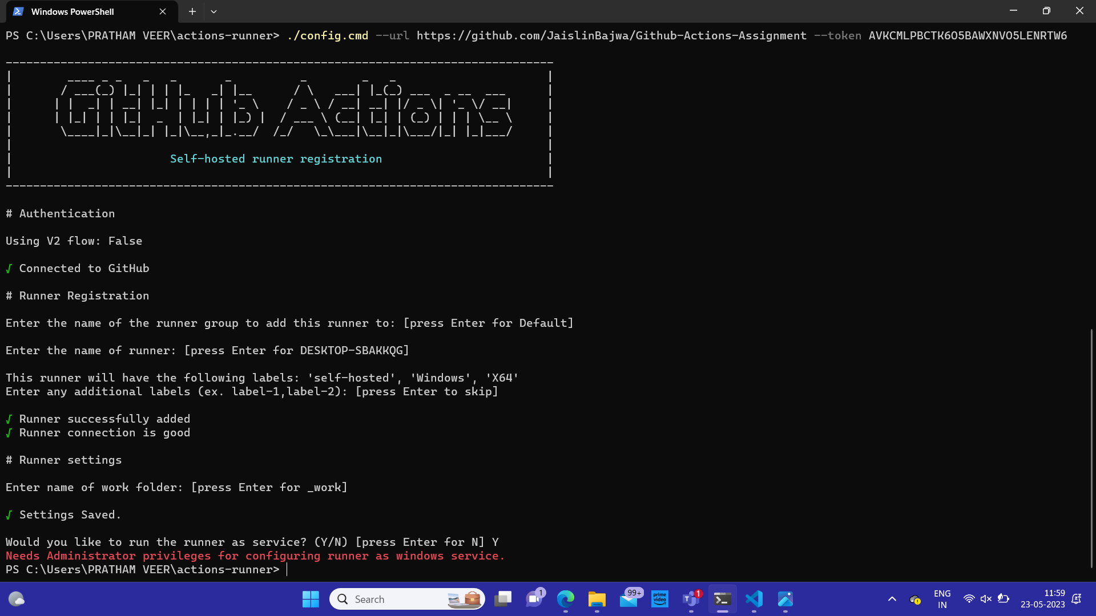

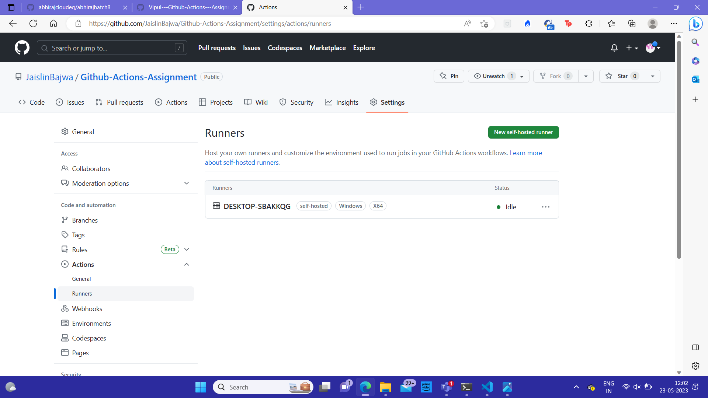

7.Test the self-hosted runner: Create a simple workflow in your GitHub repository to test the self-hosted runner. For example, you can create a workflow that runs a basic build or test task. Ensure that the workflow is configured to use the self-hosted runner.

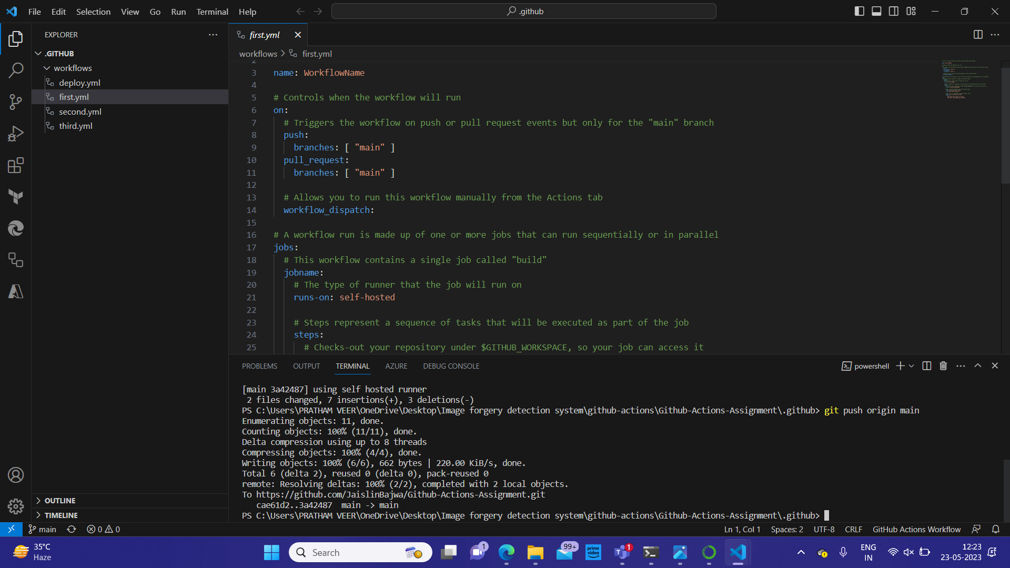

8.Monitor and manage the self-hosted runner: You can monitor the status of your self-hosted runner in the "Actions" tab of your repository. From there, you can view logs, restart or remove the runner, and manage its settings.

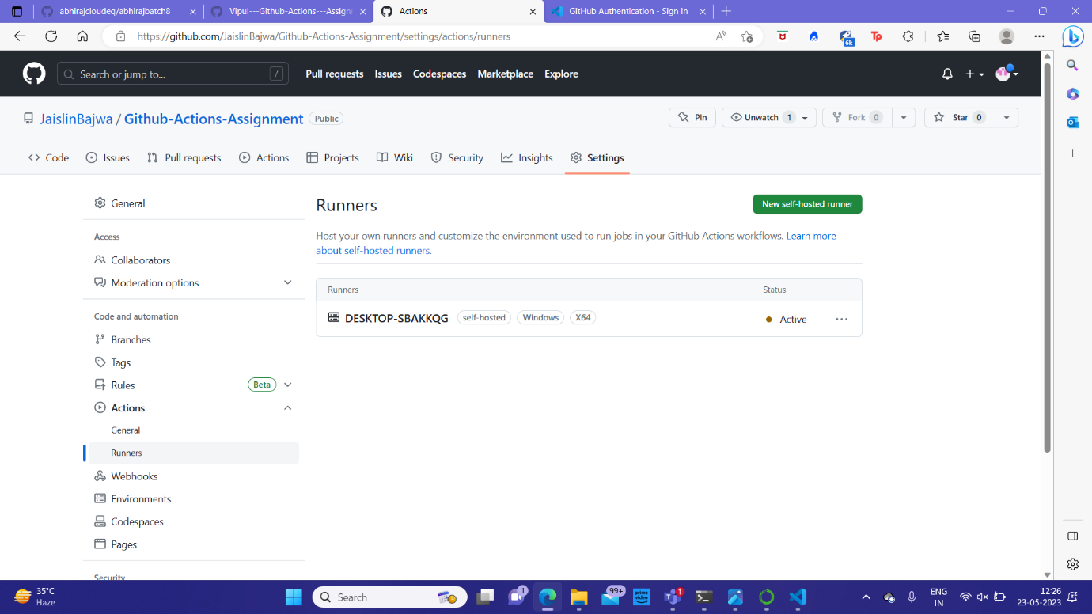

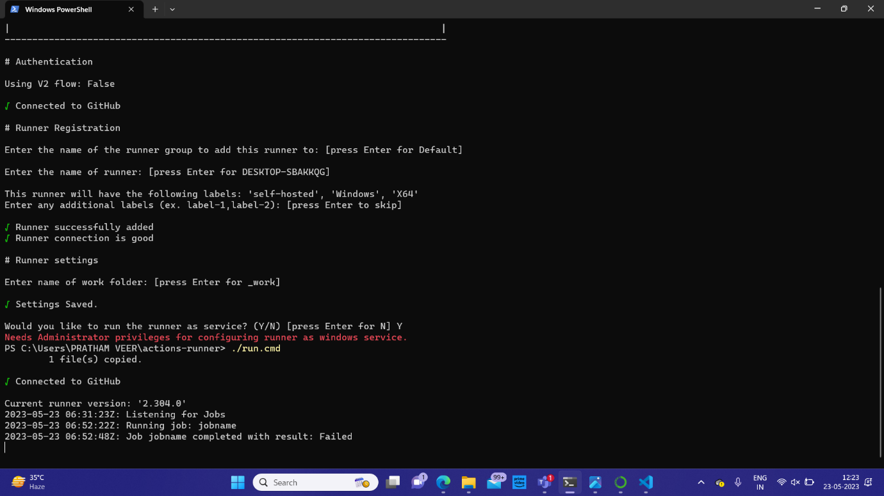

Remember to regularly update the self-hosted runner application to the latest version provided by GitHub to benefit from bug fixes, new features, and security updates.So, these were the steps involved in creating a github hosted runners.